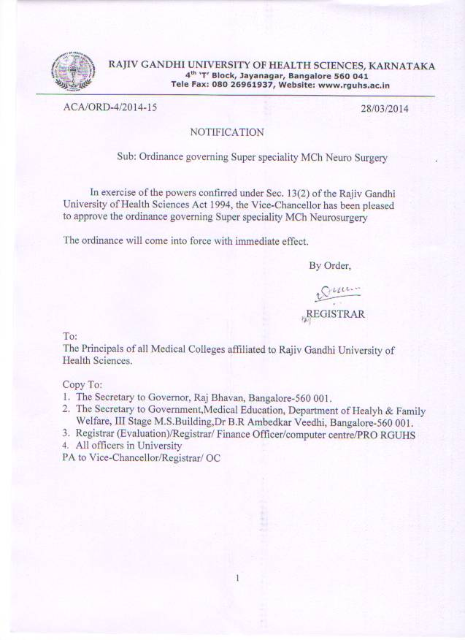

MCh Neurosurgery Curriculum

Proposed Teaching Programme

- 1st yr-
- Months 0-3.. orientation to the institution and department-introduction to OPD, ward and patient care routine
Introduction to case record maintainence
Introduction to diagnostic procedures – LP, Intubation, CT , MRI, Angiogram, etc
- Months 3-6.. allocation of patient beds
Comprehensive record maintainence
Planning and execution of diagnostic cascade
Planning and execution of pre and post operative care
Attending emergency consultations
Attending cases in emergency and casuality services
Assisting in operative procedures
- Months 6-12..further refinement of the above
Attending operation theatres
Independently attending emergency and casuality calls
Performing elective and emergency (EDH, EDH, ICH,etc) operations under supervision

- 2nd yr-
- Months 12-18.. assisting juniors in their patient care responsibilities:
Performing advanced diagnostic procedures
Performing assigned operations
Assisting seniors in complicated neurosurgical procedures
Documentation of clinical case material archiving,supervising clinical and operative work of juniors
- Months 18-24..assisting juniors in operative procedures
Performing complicated diagnostic procedures – DSA, etc
Performing simple operations under supervision (lumbar disc – MLD, laminectomy, anterior cervical discectomy, VP shunt, etc
Supervising clinical and operative work of juniors
- 3rd yr-
Months 24-36..providing peer support to juniors in all above acivities.
Rotations through allied specialities like neurology, radiology and pathology
For exposure in advanced aspects of neurosurgery
Undertakingcamps surveys clinical studies etc,as part of departmental activity from time to time
Performing higher level of surgeries like gliomas, meningiomas, etc independently under supervision
In addition to the patient care the candidates will have responsibilities in the following areas.
- Clinical responsibilities
1st yr-diagnosis of all neuro surgical disorders and patient care
2nd yr- management of complex neurosurgical disorders as well as complications of surgery and inter disciplinary problems
3rd yr-practice of protocol based management and development of such management protocols
- List of operative procedures to be performed:
The following list is a compilation of operative procedures that will be perfomed by trainees as part of the Mch (neurosurgery) programme in university. The time frame under which these procedures will be perfomed based on the degree of competence and knowledge required. As the trainee progresses through the course he will assist juniors in performing procedures under the earlier category. Similarly he will assist seniors in performing procedures under the higher category as abuild up to the performance of higher category procedure

This list consists of the most common procedures as currently practised. Additional procedures will be added to each category as and when they evolve. The classification will again be based on the degree of training and expertise required to perform those new procedures

This schedule is meant to serve as a guideline for trainees as well as for trainers. It is incumbent on both to make all efforts to fulfil the requirement.it is suggested that atleast a majority of procedures in each category upto category 4 be perfomed mandatorily.

Category 1 0-6 months

- Tracheostomy
- Burr hole
- Craniotomy opening and closure
- Exposure of spine

Category 2 6-12 months

- VP Shunt / TP shunt
- Craniotomy for EDH, SDH
- Assissting complicated procedures
- Lumbar laminectomy

Category 3 12-18 months

- Lumbar disc surgery – MLD, Laminectomy and discectomy
- Craniotomy for tumors
- Posterior fossa exposure
- Assissting major procedures

Category 4 18-24 months
- Anterior cervical discectomy and fusion
- Lumbar fusion
- Craniotomy for CSF rhinorrhoea
- Gliomas

Category 5 24-30 months

- Spinal Instrumentation
- Cranioplasty
- Craniotomy for major tumors

Category 6 30-36 months

- Meningiomas
- Transsphenoidal surgery
- Neuroendoscopy
- Detethering and Myelomeningocoele closure

- Teaching learning responsibilities
1st yr- presenting journal clubs, UG medical teaching,PG teaching of surgical trainees, and trainees in other specialities, traching para medical staff
2nd yr- presenting seminars, critical appraisal of presentation of papers, presenting papers in regional and national conferences
3rd yr- developing and reading specific projects related to neurosurgery, guiding juniors and peers in academic activities and presentations

- Schedule of departmental activities.
PG departments of neurosurgery have evolved a variety of departmental training activities. The following schedule shall serve as a guideline with further refinements being made wherever necessary

Activity frequency
- Clinical rounds thrice weekly
- Journal clubs once weekly
- Seminars once weekly
- Audit/ statistical meeting once weekly
- Inter departmental meetings
    - Neurology fortnightly
    - Radiology fortnightly
    - Pathology monthly
    - Radiation oncology monthly
    - Inter-institutional monthly/bi-monthly

- Orientation
  - Library
- The PG student will become familiar with books , periodicals and other publications pertaining to neurosurgery. A list of such books will be on record in the dept.
- Laboratory procedures
The candidate will familiarize himself or herself with the different diagnostic procedures in neurosurgery through a process of interactions with the depts..
Needs further elaboration.

Research
The component of research shall be promoted by encouraging the candidates to undertake projects during 1st 2 ys of course. This objective can be achieved by an intra mural programme or by enrolling pg’s in extra mural programme providing the necessary training.

- National programmes
The PG’s will be familiarised with national programmes pertaining to Neurosurgery. The department will encourage intra departmental activities that will increase awareness of these programmes. All programmes directly appilicable for neurosurgery and ment for implementation will be duly implemented
- Regulations
The PG,s will be sensitise to regulations to various acts such as The medical Council Of India act, Code od Medical Ethics,Transplantation of human organs Act etc. This will be done through a process of informal contact and engagement of experts in the field

Lecture Schedule with Topics
The following is a general list of topics to be covered during the course.this list is only representative, and any topic relavant to the science of neurosurgery ma be included. Teaching learning evaluation wil, therefore, not be confined to , but shall include the topics listed below.

Basic Sciences as applied to neurosurgery
- Surgical anatomy of central nervous system
- Normal physiology of central nervous system
- Neurosurgical biochemistry
- Neurosurgical endocrinology
- Physiology and pharmacology of central nervous system
- Genetic determinants of neurosurgical diseases
- Embryology and normal development of central nervous system
- Embryology of congenital anomalies of central nervous system
- Arachnoid cyst
- Encephalocele
- Myelomeningocele
- Craniosynostosis
- Dandy-walker malformation
- Chiarri malformations
- Requires further elaboration
- Neurosurgical function in foetuses and neonates
- Neurosurgical examination and diagnostic techniques
- Lumbar puncture
- CT, MRI,,DSA and other imaging modalities
Infections and inflammations of central nervous system
- Host defence mechanisms against central nervous system infections
- Bacterial infections of CNS-diagnisis and management
- Management of acute and chronic meningitis.
- Management of subduram empyema
- Diagnosis and management of cerebra abcess
- Diagnosis and management of ventriculitis.
- Diagnosis and management of spinal infections.
- Diagnosis and management of discitis.

Neurosurgical trauma
- Diagnosis and management of extradural haematoma, subdural haematoma, cerebral contusions
- Diagnosis and management of spinal cord injuries.
- Diagnosis and management of penetrating brain trauma.
- Diagnosis and management of cerebrovascular injuries.
Spinal cord disorders
- Evaluation and management of spinal cord tumors.
- Evaluation and management of degenerative spine diseases
Neuro oncology
- Overview of cancer biology and principles of neuro oncology
- Pediatric neuro oncology
- Benign and malignant tumors of CNS in adults
- Meningioma
- Glioma
- Ependymoma
- Pituitary gland tumors
- Intra ventricular tumors
Radiotherapy in CNS tumors
Chemotherapy in CNS tumors
Immunotherapy in CNS tumors
Gene therapy in CNS tumors
Other advanced therapeutic modalities in neurosurgical tumors

Pediatric neurosurgery
- Encephalocele
- Myelomeningiocele
- Spina bifida
- Spinal dysraphism
- Craniosysnostosis

Neurovascular surgery
- Congenital malformations
- Aneurysms
- Cerebrovascular accidents
Electrophysiological disorders
- mesial temporal lobe sclerosis
- hippocampal sclerosis
- surgeries for intractable seizures
neuro urology
- neurophysiology and pharmacology of micturion and continence
- patho physiology of neurovescical dysfunction
- cns disorders
- spinal trauma
- sponal dysraphism
- diabities
operative neurosurgery
- surgical approaches to the brain
- surgical approaches to the spine
endoscopic neurosurgery

Practical training and postings
Practical training has been elaborated in the teaching programme section
Postings :
I year: Casualty, Wards and ICU
II year: Wards, ICU , OT and 1month neurology and radiology postings
III year: OT ,ICU,Post operative duties and 1month of pathology and 1 of observer posting in the neurosurgery department in an another recognized institute, 3 months trauma posting in
NIMHANS

Format of logbook

Table 1: Academic activities attended
Name: Admission year
College:
Date | Type of activity  Specifiy Seminar,Journal club,Presentation, UG teaching | Particulars

Table 2 : Academic presentations made by the student
Name: Admission year:
College:
Date | Topic | Type of presentation  Specify Seminar, Journal club,presentation, UG teaching etc

Table 3 :Diagnostic and Operative procedures performed
Name : Admission year:
College:
Date | Name | ID No | Procedures | Category  O,A,PA,PI

Key : O-Washed up and observed
A-Assisted a more senior Surgeon
PA-Performed procedure under the supervision of a senior surgeon
PI-Performed independently

9. Facilities for research and publications
Apart from Central Research laboratory there is a skills lab for research and publication facility is available.

10. Periodic Evaluation of Training , internal assessment and other assessment programmes

- Monitoring of teachin/learning activities

Activity | Periodicity of assessment | method
1.journal clubs | monthly | Faculty and peer review as per check list
2.seminars | monthly | Faculty and peer review as per check list
3.theory knowledge | Six monthly | Written test
4.clinical performance | Six monthly | Clinical exam
5.operative work | Six monthly | Log book
6.research and presentation | Six monthly | Logbook and faculty peer review using  check-list
Apart from the regular evaluation programmes a mock exam (theory and practical) will be conducted 1 month prior to the final university examination.
The performance of candidates under these heads will be conveyed to them every 6 months and a record will be maintained in the dept. The Department Head or Director will fulfill all University requirements pertaining to such assessment and keep the University posted 6 monthly.

